
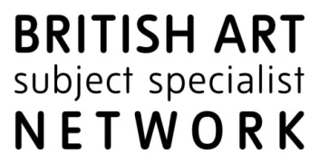



Joint Subject Specialist Network Conference
Why Exhibitions? Strategies, audiences, and future directions
21 - 22 February 2018
Tate Britain | National Portrait Gallery | National Gallery

BOOKING FORM
To apply for a place please email your completed booking form by 1 February 2018 to:
Dr Flavia Dietrich-England
National Programmes & Research Centre Co-ordinator (National Gallery)
flavia.dietrich-england@ng-london.org.uk

Please ensure that you have received confirmation of your place prior to attending the conference.

Your details
Name
Role
Organisation
Email address
Will be included on the delegate list.
Contact phone number
For office use only

Please state which parts of the conference you will be attending:
☐ Wed. 21 Feb. (evening reception with key note) + 22 Feb. 2018 (full day, incl. lunch)
☐ Thu. 22 Feb. 2018 only (full day, incl. lunch)

SSN membership
Please check all that apply:
☐ British Art Network ☐ European Paintings pre-1900 ☐ Understanding British Portraits

Special dietary requirements (other than vegetarian):

Access requirements:

Are you applying for a travel bursary?
Please note travel bursaries are issued on a first come, first serve basis.

☐ No ☐ Yes – Please provide details on the next page

Travel bursary application – Joint SSN Conference ‘Why Exhibitions?’
21 - 22 February 2018
Tate Britain | National Portrait Gallery | National Gallery

Travel costs must be based on the most cost effective travel option. Where support is confirmed by email, delegates will make their own travel bookings. Reimbursement of the agreed sum will be made by the relevant SSN after the delegate has attended the conference.

Delegate name & Organisation:

Reason for travel bursary application:

Details of travel (means of travel, to/from, dates) and breakdown of costs:

